Documentation of NBSC’s Mapping of Student-Usable Computers and Printers.

**1. Members**

• Igcalinos, Christian Dirk Axel S.

• Magdura, Roland T.

• Cescar, Joseph Benidict

**2. Project Overview**

**2.1 Purpose**

The purpose of this platform is primarily as a map of the school’s student-usable computers and printers, though we developed elementary features on how it can be further expanded based on the school’s needs. Its purpose is to allow students to inform each other when using certain school facilities.

**2.2 Key Features**

**• Use/Reserve**

Students can individually reserve and use a room. This should be used for when they’re using the room outside their class schedules. Upon pressing the “use” button, the polygon of that room will turn orange.

**• Free**

After use, students can free their position. This is intended to be used with “Use/Reserve.”

**• Occupy**

Occupy is meant for students to mark a room as “occupied” for reasons such as: a class session being held, an on-going meeting, under maintenance, etc… Once pressed, turns the color of the respective polygon into red.

**• Search**

By entering characters on the input field on the navigation bar, users can filter unwanted pins to efficiently locate certain areas.

**• Clear**

To de-occupy a room after occupying it. After pressing, the polygon of its respective room will turn “green”—the default color signifying an “unoccupied” and “unreserved” room.

**• Leaflet map w dedicated pins and dynamic polygons**

A leafletmap calibrated to show the location of our school with dedicated pins and polygons for representing the location of student-usable computers and printers.

**3. Web Application Structure**

**3.1 Website**

**• Universal**

+ Navigation

**• Home Page**

+ Search bar

+ Web Application

+ Instructions

**• About Us page**

+ Mission & Vision

+ Our company

+ Our values

+ Members list w email addresses (fake).

**3.2 Core**

**• Coding and Deployment platforms:** VS code and Github.

**• Script writing languages:** HTML, CSS, and JS.

**• APIs used:** Leaflet map.

**• Coding format:** OOP (3 of the 4 fundamentals).

**• Functions:**

+ Add, Free, Occupy, and Clear.

+ Create, add, delete, and modify html elements/tags.

+ Leaflet pins and polygons.

+ JSON fetcher.

+ Dynamic pin rendering

+ Dynamic polygon colors

+ Basic events

**4. Application workflow/Manual**

• Enter website

• Search or select pin of desired room

• Press desired action

• Free or Clear after use.

**5. Technical Details**

**5.1 Fetch JSON and Filter data**

Fetches JSON file “map.json,” then initializes the “map” div element through the “mapHandler” method so the data from the JSON file can be projected onto it using the “loadMapData” method. If input is detected on “query,” a.k.a., the search bar, its value is sent to the “searchLocation” method, where the it is used to filter-out non-matching data from JSON.

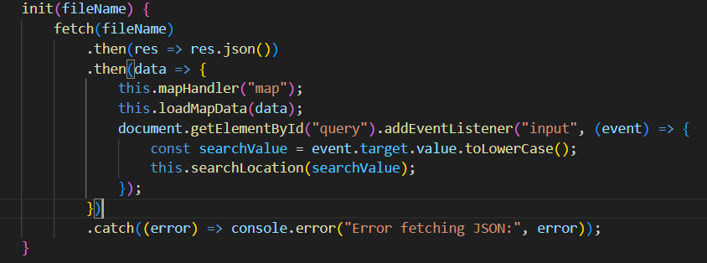

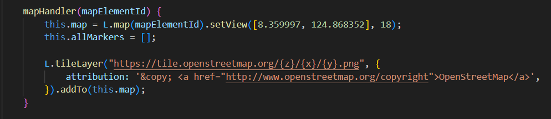

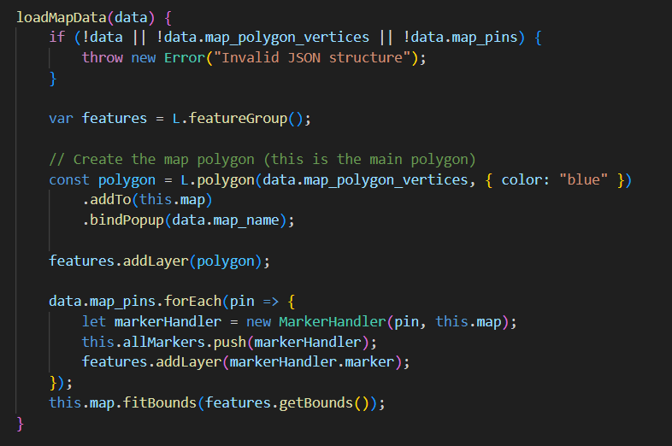

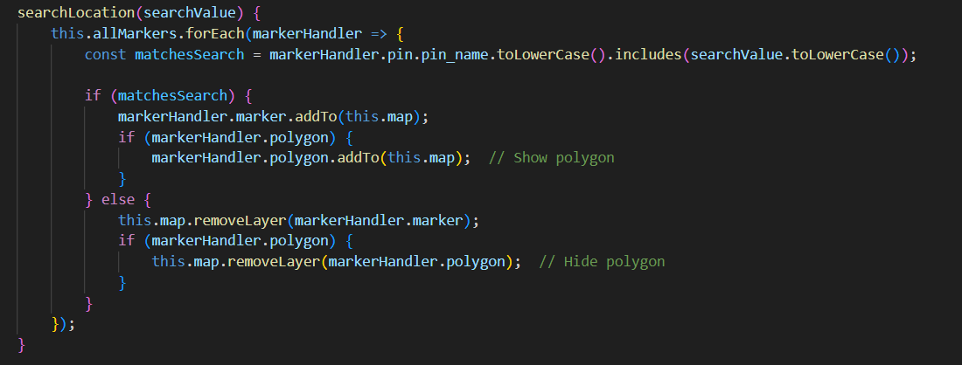

**5.2 markerHandler()**

**• Initializes:**

+ **isReseved:** used for room reservation.

+ **isOccupied:** used for room occupation.

+ **pcNum:** used for counting reservations of each room.

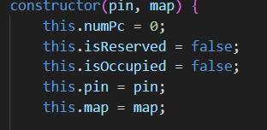

**• Event Listener**

Assigned to every pin on the map. If said pins are pressed, will

call the “handClick” method.

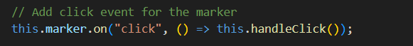

**5.3 handleClick()**

**• Creates html elements for:**

+ Location name, its # of PCs and printers, and status.

+ Buttons: Use/Reserve, Free, Occupy, and Clear.

+ Image of location.

**• Dynamic Information rendering and Polymorphic Button**

Status shown in the paragraph html element “info” changes according to specified value of “numPc.” If it’s equal to the number of PCs in a specified room, it’ll show “occupied.” Otherwise, it will show its int value.

Reserve button inner text value changes depending on state of Boolean, “isOccupied.” It also alerts users if its press when a room is occupied.

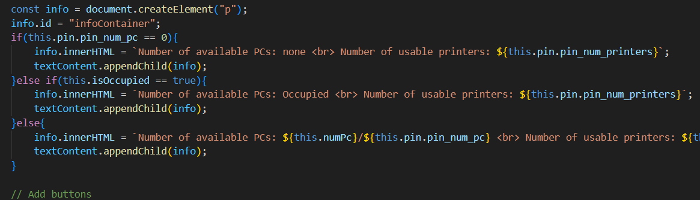

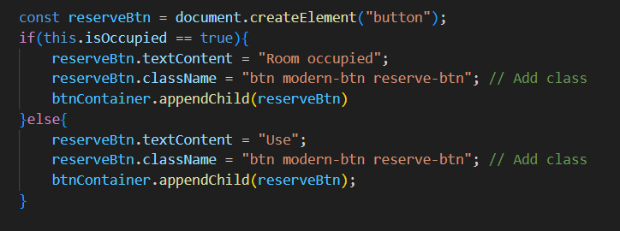

**5.4 Botton Event Listeners and their methods**

**• reserveBtn and reserveBtn()**

Alert method is triggered is “isOccupied” is true, otherwise, it calls its respective method. As long as “numPc” < the amount of PCs the select room, it’ll increment it by one, set “isReserved” to “true”, and set the room’s polygon color to orange. However, if numPc == number of PCs in a room, then switches “isReserved” to “false” and “isOccupied” to “true” and turns the room’s polygon color to red.

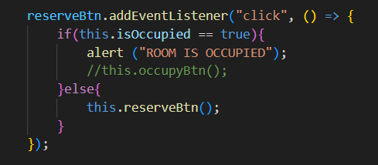

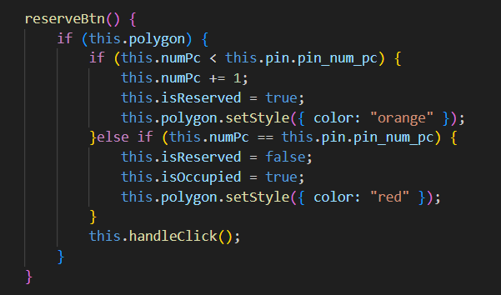

**• freeBtn and freeBtn()**

Calls its method and if numPC is 0, then triggers alert method. If numPC is > 0, but < the number of PCs in a room, it turns “isOccupied” to false recolors the room’s polygon and updates the card. If numPC == 0, it turns the polygon color to green.

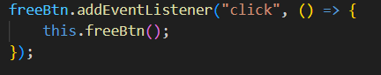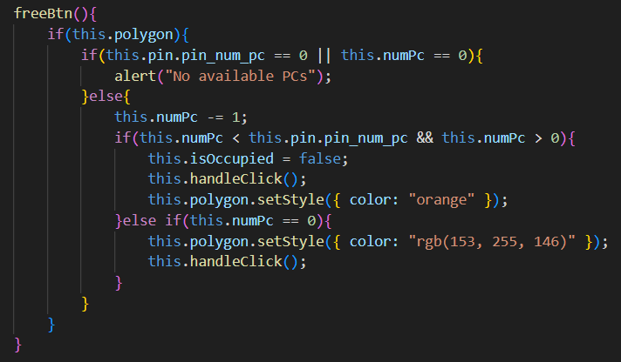

**• occupyBtn and occupyBtn()**

Alert method is triggered is “isReserved” is true, otherwise, it calls its respective method. Turns “isOccupied” to “true” and recolors room’s polygon to red.

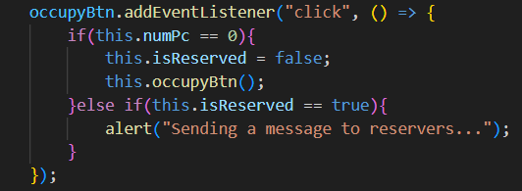

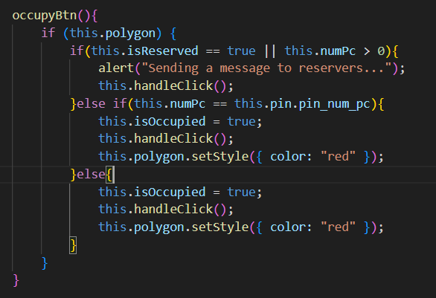

**• clearBtn and clearBtn()**

Resets all Boolean to false, numPc val to 0, and polygon color back to green.

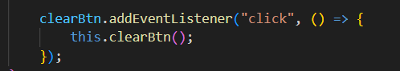

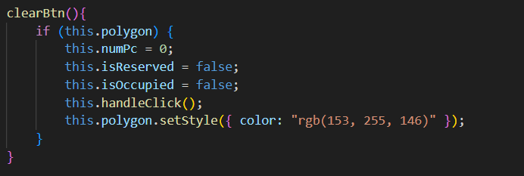

**6. Future Implementation**

The example features presented in this web app, i.e., buttons and the dynamic displaying of info can be further expanded with further development. The purpose of these features was to allow students to inform others if a room is being reserved or occupied.

The primary goal of this project is to map-out the student-usable PCs and Printers in order for students to become familiar with their locations. Speaking of “mapping-out,” this project can be further expanded to include other facilities, if not, all of them as well.

**7. Troubleshooting**

To be able to reserve a room if it’s occupied, press “clear.” Likewise, to occupy a reserved room, press “free” until its polygon color turns green.

**8. Conclusion**

NBSC map of student-usable computers and printers is an innovative way of enabling students to familiarize with the location of certain school facilities and services. It also showcases one of the many possible features that can be implanted in a mapping project such as this, which will greatly enhance the experience of the students looking to fully utilize them.